Riphah International University Lahore



Object Oriented Programing

BS Computer Science

2nd Semester

Presented By: Faqeeha Muqadas (46533)

Presented To: Ms. Madiha

**Question: 1**

# include<iostream>

using namespace std;

class Baby {

private:

bool isHungry;

bool isSleepy;

public:

Baby() {

isHungry = false;

isSleepy = false;

}

void setHungry(bool value) {

isHungry = value;

}

void setSleepy(bool value) {

isSleepy = value;

}

void cry() {

if (isHungry) {

cout << "Baby is hungry. aaaaah!" << endl;

}

if (isSleepy) {

cout << "Baby is sleepy. aaaaah!" << endl;

}

}

};

int main() {

Baby baby;

// Set flags to indicate the baby's needs

baby.setHungry(true);

baby.setSleepy(false);

// Check the flags and make the baby cry if needed

baby.cry();

return 0;

}

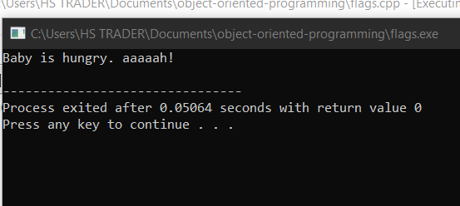

**Question: 2**

// Pin validation

#include<iostream>

#include<string>

using namespace std;

class PinCheck {

public:

bool validateInput(const string& pin) {

bool hasUpperCase = false;

bool hasLowerCase = false;

bool hasDigits = false;

for (char c : pin) {

if (isupper(c)) {

hasUpperCase = true;

}

else if (islower(c)) {

hasLowerCase = true;

}

else if (isdigit(c)) {

hasDigits = true;

}

}

if (pin.length() >= 8 && hasLowerCase && hasDigits) {

return true;

}

return false;

}

};

int main() {

cout << "Name: Faqeeha Muqadas" << endl;

cout << "Sap ID: 46533" << endl;

PinCheck check;

string userInput;

cout << "Enter a pin (at least 8 characters including uppercase, lowercase, and digits):" << endl;

getline(cin, userInput); // Read the entire line of input, including whitespaces

if (check.validateInput(userInput)) {

cout << "Valid pin." << endl;

}

else {

cout << "Invalid pin." << endl;

}

return 0;

}

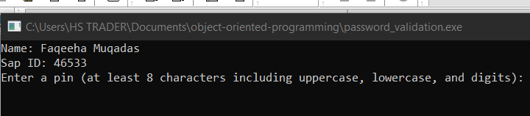

Question: 3

//Program for input validation

#include<iostream>

using namespace std;

class AgeValidation {

public:

int validInput(int age) {

if (age >= 10 && age <= 90) {

return 60;

}

return 55;

}

};

int main() {

AgeValidation validation;

int userInput;

cout << "Name: Faqeeha Muqaadas" << endl;

cout << "Sap ID: 46533" << endl;

cout << "Enter your age: ";

cin >> userInput; // Accept user input and store it in userInput variable

int result = validation.validInput(userInput); // Call validInput method with userInput as argument

cout << "The result is: " << result << endl;

return 0;

}

